In The Name of God

Collection of Maharishi’s Analogies, Principles and Qualities discussed

in

the Science of Creative Intelligence course

Prepared By

**Hassan Habib**

Reviewed By

**Prof. John Collins**

*Hassan says: The author of this collection does not necessarily believe in what is mentioned in it. He firmly disagrees with some of it; however, this document was published only for academic purposes.*

*Prof John says: Our thanks to Hassan for producing this document. I have reviewed it and am happy to say I do agree with everything in it.*

2013

**The Analogies**

1.The Walking Analogy:

This is when someone is walking and he rests one foot, walks forward with the second, and then he rests the second and moves the first foot.

Principle: The mind needs to rest in order to be active so the mind needs to go into a deep state of silent alertness in order to go on with life and be more creative and productive. Also:  ‘Activity rests on rest.’ Also progress comes in steps of rest and activity.

2.The Running/Walking/Standing Analogy:

A man who can run can certainly walk, and if a man can walk he can stand still. The ability to be still is contained in the ability to move.

Principle:  In relation to the Transcendental Meditation ©  if we have the ability to experience active states of the mind then we also have the ability for the mind to be still. This stillness is transcendental consciousness.

3.Congo/Banana/Germany Analogy:

When someone in Congo brings a banana to Germany he introduces it to the society and then it gets well known across the community

Principle: New ideas are introduced by an individual so the whole society can benefit from it. Thus the individual is the unit of society.

4.Bow and Arrow Analogy:

To fire an arrow to hit the target we first pull the arrow back in the opposite direction. The further we pull it back the faster it will travel to the target. When we have pulled the arrow back it is in a state of restful alertness ready to fly into dynamic action.

Principle:  Like this, for the mind to accomplish its goals in life, it is good to first go into the state of deep rest of transcendental meditation. The state of restful alertness is the best preparation for dynamic activity.

5.Muddy Water Analogy: When the water is muddy it gives a muddy reflection of the sun. If we purify the water the reflection of the sun becomes more clear. When the water is completely purified then the reflection of the sun is very good.

Principle: Like this is the human nervous system is muddly (ie full of stresses and strains) then it can reflect creative consciousness then it can only reflect a low level of creative intelligence. But if the nervous system is pure ess very fully and support higher levels of consciousness.

6.The Table Analogy:

When you pull one leg of a table the whole table comes.

Principle: When you contact pure creative intelligence in meditation, all aspects of life improve.

7.The Driving Man and the Tree Analogy:

When a man is not aware while driving he might hit a tree.  When the man is aware, however, he may avoid the curves of the road and drive safely.

Principle: Knowledge is structured in consciousness and is different in different states of consciousness. When consciousness is dull then perception will be unclear.  When the mind is alert the perception is clearer and action is more skillful.

8.The Diamond Analogy:

When a man holds a diamond he should know intellectually how valuable it is. Otherwise he might just feel its weight and throw it away.

Principle: In order to get a better understanding of the value of meditation, it is good to study the science of creative intelligence.

9.The Bulb Analogy:

One light bulb can light a whole room. A very bright bulb can light a very large room.

Principle: Like that, an individual who reflects the value of creative intelligence and brighten up the lives of his surroundings. Someone living the full value of creative intelligence in Unity Consciousness can have a big positive influence in society.

10.The North and South Pole Analogy:

When the north and south pole of a magnet are strengthened the whole magnetic field gets strengthened as well.

Principle: When the diverse values of individuals in a society are strengthened by living the full value of creative intelligence, then the whole society is strengthened.

11.The House and The Bricks Analogy: A house is made of many individual bricks. But when they are all put together  the design and compilation of the bricks makes a home.

Principle: The whole is more than the sum of the parts. A society isn't just some random collection of individuals. All the individuals go into making up a unique nation and culture.

12.School and Students Analogy:

The school does not come to the student.  The student has to go to the school.

Principle: There has to be a desire by the individual to get the Knowledge or otherwise the Knowledge won't be earned at all.

13.The Diving Analogy:

In order for someone to dive skillfully into the sea he has to set up an angle first to dive into the sea.

Principle: When we sit for transcendental meditation, we take the correct angle by starting the mantra very easily and effortlessly.

14.The Child and Mother Analogy:

The closer the child gets to his mother, the faster he walks (or crawls).

Principle: The closer the mind goes deep to the cosmic mind the faster it goes.

15.The Car and the Airplane Principle:

The faster the ride is the more comfortable it becomes, so is the airplane is faster than a car, moreover an airplane is more comfortable than a car.

Principle: The technique and mantras of transcendental meditation are like a jet plane method. They enable one to reach to the pure level of consciousness quickly and comfortably.

16.The Bank and the Market Analogy:

One has to go the bank first to collect the money before he can go to the market to buy goods.

Principle: The Mind has to gain the full power of creative intelligence first in order to go into the manifestation and action in life.

17.The Flower and the Sap Analogy:

a) The sap nourish every aspect of the flower including the petals, the leaves and the stem.

Principle: So the un-manifested aspect of life, pure intelligence nourishes every aspect of manifested creation.

b) When a flower is not in good shape a skillful gardener waters the root.

Principle: Principle of the second element. Also do less and accomplish more. Rather than trying to paint the leaves green and prop up the stem etc, one simple action of watering the root nourishes the whole plant. Like that one action which is contacting transcendental consciousness nourishes all aspects of life.

18. Strawberry Analogy:

When someone describes a strawberry, he can learn intellectually about the tiny seeds, the deep red, heart-shape of the fruit.  Yet until one takes a bite, he cannot be fully aware of the essence of this fruit.  Smelling it might indicate a certain sense of sweetness, but until an actually bite is taken, the flavor savored, and the strawberry is fully swallowed, can one know for sure about the nature of the strawberry.

Principle:  Full knowledge consists of both intellectual understanding and experience. For instance, we can describe higher states of consciousness intellectually, but we will only fully have knowledge of cosmic consciousness when we experience it.

19.Ocean and Wave Analogy:

A Single wave in the ocean can not be isolated from the rest of the ocean. The individual wave affects the ocean and the ocean affects the individual wave.

Principle : Like that, an individual can not be considered separately from the society as the individual is the structural unit of the society. The individual affects collective consciousness and collective consciousness affects the individual. There is a reciprocal relationship.

20.The Curtain Analogy:

Consider a window that is covered by three different types of curtains. They all block the light behind them, but in between the curtains where there is a little gap, the light shines through.

Principle : These three curtains are like the first three states of consciousness ; waking and dreaming and sleeping; however the light behind these three is the pure consciousness. So these three states of consciousness conceal the experience of pure consciousness. but in the transition from one state to another we see a moment of pure consciousness shining through. This is seen in the EEG results and is called the junction point model.

21. The Movie Screen Analogy:

One can never watch a movie or a show if they don’t have a screen first to view  them on it.

Principle : Like that, The first three states of consciousness would never have been if one didn’t have pure consciousness.

22. The Skin Boil Analogy:

When the boil appears on different parts of the body it’s better to take the medicine to cure the source of the skin boil rather than trying to cure each part on it’s own; or otherwise the disease will continue.

Principle : The second element. The United Nations tries to solve the single problems that occur on different parts of the world on the level of the problems ; but that’s not enough; because that doesn’t solve the source of the human suffering which is the low level of consciousness that is the source of human weakness.

23. The Ripples on the lake analogy:

When one throws a stone in a lake the ripples spread out and the whole lake gets affected by the action of the individual pebble.

Principle : The actions of the individual affects the whole progress of the society.

24. The Grass and Flower Analogy:

Both Grass and Flower glorify each other in the general view ; the flower glorifies the grass by it’s flourishing colors and the grass glorifies the flower by surrounding it.

Principle : Same like that, the consciousness individual is glorified by it’s surrounding environment and what he does glorifies it as the environment.

25.The Fort Analogy:

When one takes hold of a fort, he takes control of all of the territory with it.

Principle:  Principle of the highest first. Do the most important thing first. The most important thing in life is to contact the source of thought, the pure level of creative intelligence. This one action will nourish all aspects of a man’s life. This is also an example of the principle of do less and accomplish more.

26. The lever analogy.  When a big rock blocks the path, 10 men cannot move it. But one man using a lever can throw the rock aside.

Principle: Do less and accomplish more. Knowledge and skill in action lead to great accomplishment

27. The Snow plow analogy. The snow plow can do two things: it can move forward and it can remove the obstacles to progress.

Principle:  Like that in SCI and Transcendental Meditation, the technique is given to go to the source of thought and also to remove the obstacles (stresses) that block that path.

28. Seed and tree analogy:

Take the example of a mango tree. Now [there is a] mango tree and seed and tree and seed and tree and seed, and then after fifty years or hundred years, whatever time, the tree falls down. But the same [type of] mango seed brings the same [type of] mango tree. After fifty or a hundred years, that tree falls down. But the same seed brings same tree, same tree, same tree.

Principle: In this change, what we find is continuity. That means the change is subject to non-change over time, over time, over time. So, whatever is changing, whatever is changing, whatever is changing—listen to this—whatever is changing, whatever is changing, whatever is changing is always changing. And always changing means eternally changing. And that eternal value makes the change eternal—just a thought of it.

29. The Dust Analogy:

When one cleans a room, he will not notice the dust being removed while cleaning. The individual dust particles are not easily seen with the naked eye nor are they tended to individually.

Principle:  So it is with TM. The thoughts come out while your mind is preoccupied finding the pure consciousness and each individual thought can be ignored while the mind seeks full consciousness.

30. The Pipe , Cup and the Bucket Analogy :

To retrieve water from a pool of water, one must carry it in some sort of container.  This could be a pipe, a cup or a bucket.  Using a bucket will allow one to carry more than would be possible with a small container or without a container.

Principle:  Likewise, with regular meditation, the mind can broaden.  The source of thoughts, knowledge, and intelligence equally increase. This is your container of knowledge.

fas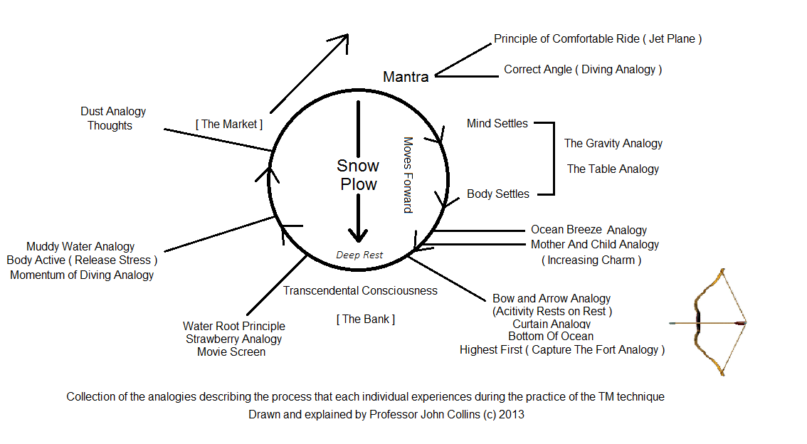

**The Principles**

1. Do less and accomplish more. (The Lever Analogy )
2. Principle of the second element. “bringing light dispels the darkness immediately”
3. If there’s a problem, there’s weakness (Skin Boil Analogy)
4. Principle of the highest first. (The Fort Analogy)
5. Principle of gravity (The Diving Momentum Analogy)
6. Principle of increasing charm (Child and Mother Analogy )
7. Principle of least action (Flower and Sap Analogy)
8. Principle of purification of the path (Snow Plow Analogy )
9. Principle of the comfortable ride.  (The Car and the Airplane Analogy)

**Qualities of Creative Intelligence**

* **Self-sufficient:** Relates to the invincibility of the Creative Intelligence.
* **Self-perpetuating:**
* **Progressive:** in the state of restful alertness it’s progressive value starts
* **Integrative:** Bringing together opposite values manifest and unmanifest.
* **Discriminative:** Useless thoughts don’t arise.
* **Holistic:** It contains the wholeness of life.
* **Self-fulfilling:**
* **Invincible:** CI is invincible because it’s self-sufficient and vigilant.
* **Highly Selective:**
* **Purposeful:**